Bill Wolff
Web Design and Development, Fall 2022
Responsive Video and Audio Embed Media from YouTube, Vimeo, and SoundCloud
If you copy & paste this content, you may need to fix the quotation marks so they are " and not “. This tutorial is informed by https://www.ostraining.com/blog/coding/responsive-videos/.

Step 1: CSS (in main.css)

First, create the media-responsive class in the main section, which creates the box to put the media in.

.media-responsive {
overflow: hidden;
padding-bottom: 56.25%;
position: relative;
height: 0;
}

Second, style the iframe in the main section so that the video will be positioned correctly in the box and 100% responsive.

.media-responsive iframe {
left: 0;
top: 0;
height: 100%;
width: 100%;
position: absolute;
}

Step 2: HTML

Create the media-responsive class in your HTML. This can go anywhere in the <body></body> (such as in your left and right sections), but remember if you add a heading before it, you’ll need the <header></header> and <section></section> tags, too.

<div class="media-responsive">

</div> <!-- end media-responsive -->

Step 3a. Get the Embed code: YouTube.
Go to the YouTube video. Click share and copy the embed code, then go to Step 4 below.

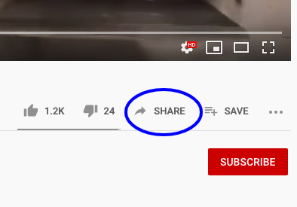 | 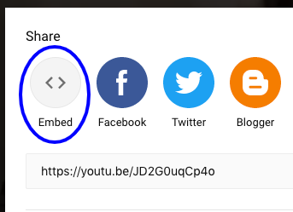 | 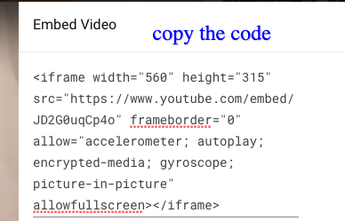
Step 3b. Get the Embed code: Vimeo

If the video you want on Vimeo, the process is basically the same, then go to Step 4 below.
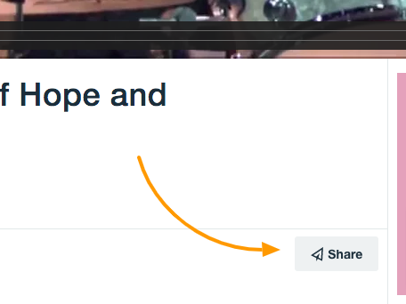 | 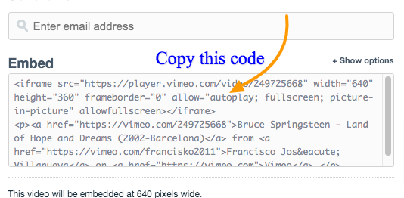

Step 3c. Get the Embed code: SoundCloud

If the media you want to embed is on SoundCloud, the process is basically the same, then go to Step 4 below.

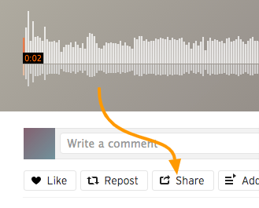 | 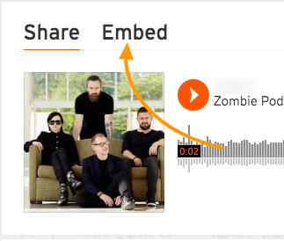 | 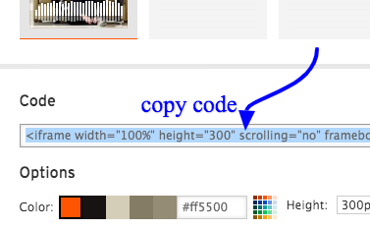

Step 3d. Get the Embed code: Any other site with embeddable media using iframes, the process will be the same.

Step 4. Paste the embed code.

Paste the embed code between in your video-responsive class.

<div class="media-responsive">

<iframe width="560" height="315" src="https://www.youtube.com/embed/JD2G0uqCp4o" frameborder="0" allow="accelerometer; autoplay; encrypted-media; gyroscope; picture-in-picture" allowfullscreen></iframe>

</div> <!-- end video-responsive -->

Step 5. Save and upload your portfolio.html and main.css.
Because media-responsive is a class, it can be used multiple times on your site so you can embed multiple media.

Step 6. See responsive media on your site!

