Bill Wolff
Popular Music, Protest, Social Justice, Fall 2023
Riot Grrrl
Create a GoogleDoc for your group, share it, and share with Bill.

- Deconstruct this cover in terms of how it visually represents the goals, practices, and beliefs of the Riot Grrrl movement, as discussed by Darms, Fateman, and in the zines themselves. Try to locate up to 5 representations. | 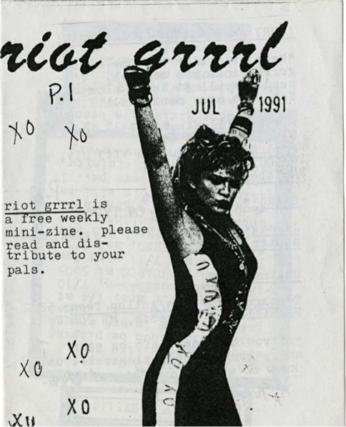

- I’d like you to locate examples where Grady’s discussion of Third Wave Feminism, pages from the zines, and sociological imagination in the lyrics intersect. Locate 2 examples. Paste in a screenshot of the zine page and the lyrics.

- Writing about the civil rights movement, Sanger suggests “that the songs of the civil rights movement were examples of purposeful communication….” (p. 3, in Sanger part 1). Later, Sanger continued, “The important consideration is not whether singing actually allowed activists to accomplish all the things the claimed for it, but, rather, that they believed it did. If activists believed singing provided them with the strength to face difficult situations, then when they sang, they were likely to find that, in fact, they did feel stronger . . . and gave this form of communication enormous power in their lives—the power that comes with expectations” (p. 18, in Sanger part 1).
I’d like you to consider how the Bikini Kill, Bratmobile, ands Heavens to Betsy songs we listened to for today and the zines and zine-making contributed a “purposeful communication” for women of the 90s punk scene and what the zines as a communication practice enabled and/or empowered the women to do and to think that they could do. Try to locate 2 examples of “purposeful communication” (1 in the songs and 1 in the zines) and paste into the document lyrics/zine pages that illustrate your point.
Don’t use the zine or songs you used in other answers.

